**Customs Tariff & HS Code-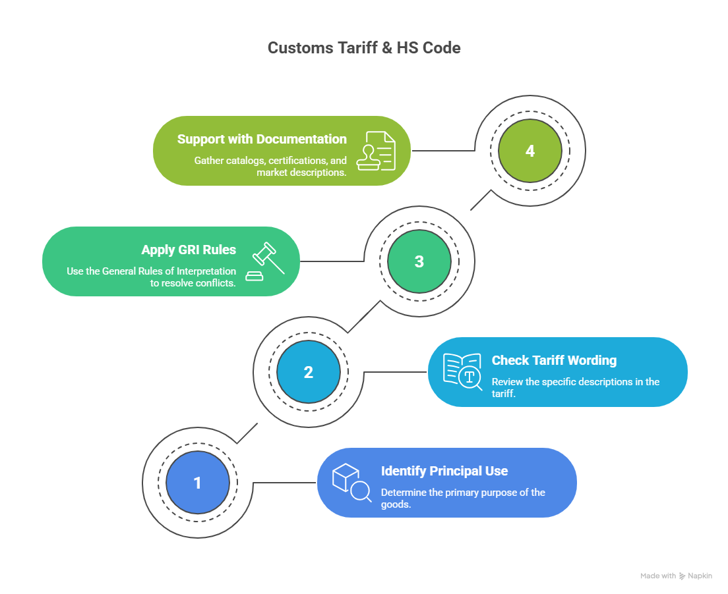Customs Tarriff:**

**1. What is the Customs Tariff?**

* In India, the customs tariff is legally defined in the Customs Tariff Act, 1975.
* It contains two schedules:
  + First Schedule → Basic customs duty rates for all imported goods, arranged by HS codes (Harmonised System of Nomenclature).
  + Second Schedule → Export duties (applied to a small number of items).
* It’s the legal base for duty rates before applying any FTA or special exemption.

**2. Customs Tariff and FTAs**

* Under an FTA, the normal duty rate from the First Schedule can be reduced or made zero.
* This is implemented via a Customs Notification issued under Section 25(1) of the Customs Act, 1962.
* Example: For India–UAE CEPA, Notification No. 22/2022-Customs specifies the reduced tariff rates for eligible products.

**3. How to Read a Customs Tariff Entry**

Every entry typically shows:

1. HS Code (8-digit in India).
2. Description of Goods.
3. Unit of measurement (e.g., kg, pieces).
4. Standard duty rate (ad valorem % or specific amount).
5. Other applicable duties → Social Welfare Surcharge, IGST, Compensation Cess, etc.

**How Customs Duty Is Calculated in India**

Customs duty isn’t a single tax—imports into India are subject to **multiple components**:

1. **Basic Customs Duty (BCD)** – Charged based on the assessable CIF (Cost + Insurance + Freight) value of goods. This can be ad valorem (percentage) or specific (per unit).
2. **Social Welfare Surcharge** – Levied at a rate of 10% on BCD, supporting domestic welfare schemes.
3. **Integrated Goods and Services Tax (IGST)** – Applied on the sum of CIF + BCD + Social Welfare Surcharge. The IGST rate mirrors the GST slabs (0–28%).
4. Other Possible Duties:
   * Anti-dumping duties
   * Safeguard duties
   * Compensation cess (on luxury items, etc.)
   * Agriculture Infrastructure Development Cess (AIDC) on certain goods

These depend on product category and origin.

**Example Import Duty Calculation**

Let’s calculate import duty for an item with a CIF value of ₹100:

Using a basic duty rate of 30%, plus IGST and surcharges:

Assessable value (A): ₹100

BCD (30% of 100): ₹30

Social Welfare Surcharge (10% of 30): ₹3

Subtotal: ₹100 + ₹30 + ₹3 = ₹133

IGST (18% of 133): ₹23.94

Total Customs Duty (Approx): ₹30 + ₹3 + ₹23.94 = ₹56.94

Total Landed Cost: ₹100 + ₹56.94 = ₹156.94

**Tools & Calculators You Can Use**

**1.**

**ICEGATE Custom Duty Calculator (Government of India)**

* Official and reliable.
* Requires login/registration.
* Calculates duty based on HS code and origin.

**Summary Table**

| **Calculation Method** | **Details** | **Best For** |
| --- | --- | --- |
| ICEGATE (Govt.) | Official, accurate; requires login | Formal declarations, compliance |

**4. Key Legal References**

* Customs Tariff Act, 1975 → Statutory framework for rates.
* Section 25, Customs Act, 1962 → Power to grant FTA-based exemptions.
* CAROTAR, 2020 → Verifying origin before applying reduced rates.
* DGFT Notifications/Public Notices → FTA operational instructions.

**5. FTA Tariff Decoding Example**

Without FTA:

* HS 61091000 (T-shirts, cotton): Basic Customs Duty = 10%.

With FTA (India–Australia ECTA):

* Tariff schedule shows → Year 1: 5%, Year 2: 0%.
* Apply Customs Notification for ECTA to claim reduced duty.

**Case Study:**

If the importer does not submit freight and insurance details, Indian Customs does not leave them blank — they use prescribed default values under the Customs Valuation (Determination of Value of Imported Goods) Rules, 2007, framed under Section 14 of the Customs Act, 1962.

**1. Legal Basis**

* Section 14, Customs Act, 1962 → Customs duty is based on the transaction value (CIF value — Cost, Insurance, Freight).
* Rule 10, Customs Valuation Rules, 2007 → If freight/insurance isn’t available, Customs will add standard amounts.

**2. Default Additions When Values Are Missing**

**A. Freight**

If freight cost is not available:

* By Air: Add 20% of FOB value or the actual freight, whichever is lower.
* By Sea: Add actual cost, or if unavailable, 20% of FOB value.

(FOB = Free on Board value = value of goods at export without freight & insurance)

**B. Insurance**

If insurance cost is not available:

* Add 1.125% of FOB value as notional insurance cost.

**3. Example Calculation Without Submitted Freight & Insurance**

Let’s say:

* FOB value = ₹1,00,000
* Mode = Sea
* BCD = 10%
* IGST = 18%
* Freight & Insurance not declared.

Step 1: Calculate CIF value

* Freight = 20% of FOB = ₹20,000
* Insurance = 1.125% of FOB = ₹1,125
* CIF = ₹1,00,000 + ₹20,000 + ₹1,125 = ₹1,21,125

Step 2: Apply Customs Duties

* BCD = 10% of ₹1,21,125 = ₹12,112.50
* Social Welfare Surcharge (SWS) = 10% of BCD = ₹1,211.25
* IGST = 18% of (₹1,21,125 + ₹12,112.50 + ₹1,211.25)

= 18% of ₹1,34,448.75 = ₹24,200.78

Step 3: Total Duty Payable

= ₹12,112.50 (BCD) + ₹1,211.25 (SWS) + ₹24,200.78 (IGST)

= ₹37,524.53